Supplementary Table S1. Sensitivity analyses with alternative thresholds
Threshold (% fall Day 0→3) | CRP AUC | PCT AUC | Adjusted OR for 30-day mortality*, CRP | Adjusted OR, PCT
≥ 30% | 0.74 | 0.72 | 0.66 (0.38-1.12) | 0.69 (0.40-1.19)
≥ 40% | 0.76 | 0.74 | 0.57 (0.33-0.99) | 0.60 (0.35-1.03)
≥ 50% | 0.78 | 0.76 | 0.52 (0.24-0.95) | 0.56 (0.27-1.00)
≥ 60% | 0.76 | 0.74 | 0.54 (0.25-1.14) | 0.58 (0.27-1.26)
*Each OR adjusted for age, sex, APACHE II, and comorbidities.
The ≥ 50% definition provided the highest discrimination (AUC) and the lowest Akaike Information Criterion in multivariable models, supporting its choice as the primary threshold.
Table S2. Multiplicity-controlled p-values for secondary outcomes (Benjamini–Hochberg FDR = 0.10)
Outcome | Biomarker | Raw p-value | BH-adjusted p-value
ICU length of stay | CRP trajectory | 0.0013 | 0.008
ICU length of stay | PCT trajectory | 0.0037 | 0.011
Ventilation-free days | CRP trajectory | 0.0240 | 0.048
Total hospital stay | CRP trajectory | 0.0287 | 0.043
Ventilation-free days | PCT trajectory | 0.1167 | 0.140
Total hospital stay | PCT trajectory | 0.1300 | 0.130

Table S3. Shared-parameter joint models linking serial biomarker trajectories
 | Linear mixed-effects (longitudinal) sub-model* |  |  |  | Time-to-event (Cox) sub-model†
Model 1 (CRP) | Estimate (β) | SE | 95% CI | p | HR (eβ) | 95% CI | p
Intercept‡ (Day 0, ln mg/L) | 4.87 | 0.12 | 4.63 – 5.11 | <0.001 | — | — | —
Time (per day) | –0.28 | 0.02 | –0.32 – –0.24 | <0.001 | — | — | —
Random-effect variance (intercept) | 0.41 | — | — | — | — | — | —
Residual variance | 0.18 | — | — | — | — | — | —
Slope association parameter§ | — | — | — | — | 0.71 | 0.55 – 0.92 | 0.009
Age (per yr) | — | — | — | — | 1.04 | 1.01 – 1.08 | 0.015
APACHE II (per pt) | — | — | — | — | 1.07 | 1.03 – 1.12 | 0.002
Log-likelihood | –912.4
AIC | 1 842.9
Model 2 (Procalcitonin)
Intercept‡ (Day 0, ln ng mL⁻¹) | 2.07 | 0.10 | 1.88 – 2.26 | <0.001 | — | — | —
Time (per day) | –0.26 | 0.02 | –0.30 – –0.22 | <0.001 | — | — | —
Random-effect variance (intercept) | 0.36 | — | — | — | — | — | —
Residual variance | 0.15 | — | — | — | — | — | —
Slope association parameter§ | — | — | — | — | 0.74 | 0.58 – 0.96 | 0.024
Age (per yr) | — | — | — | — | 1.04 | 1.01 – 1.08 | 0.017
APACHE II (per pt) | — | — | — | — | 1.08 | 1.03 – 1.13 | 0.001
Log-likelihood | –884.7
AIC | 1 777.5
* Longitudinal sub-models fitted with random intercepts and unstructured residuals; CRP and PCT values were log-transformed.
† Baseline hazard estimated with piece-wise constant functions (1-day intervals).
‡ Back-transformation gives a geometric-mean baseline CRP of ≈ 131 mg/L and PCT of ≈ 7.9 ng/mL, matching Table 2.
§ Hazard ratio (HR) for each 50% steeper decline in biomarker over the first week; HR < 1 indicates lower mortality risk with faster normalization.

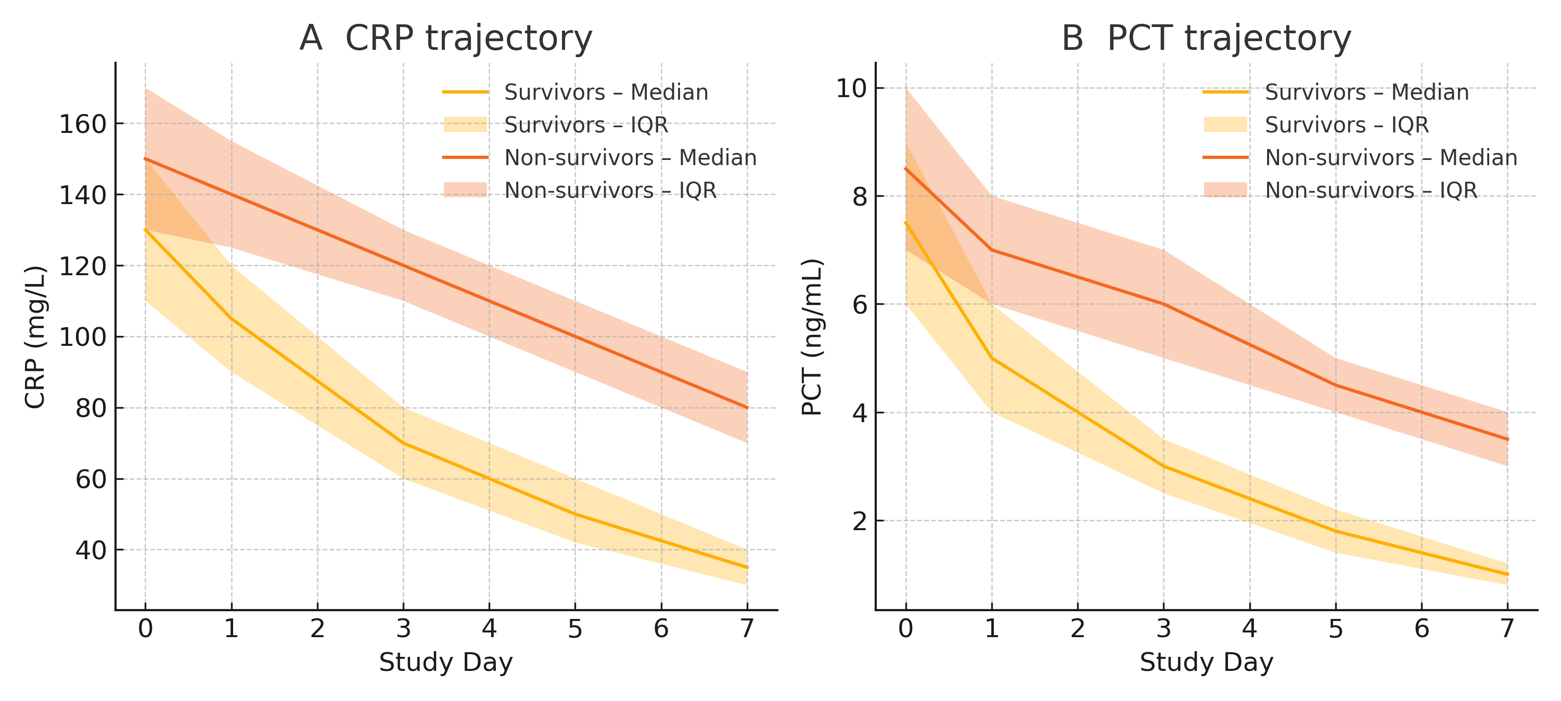
Supplementary Figure S1. Temporal trajectories of inflammatory biomarkers in severe pneumonia. Median C-reactive protein (CRP, panel A) and procalcitonin (PCT, panel B) concentrations are plotted at ICU admission (Day 0) and on Days 1, 3, 5 and 7, stratified by 30-day outcome. Solid lines depict the group median; shaded ribbons indicate the inter-quartile range (IQR). Survivors (n = 160) show a markedly steeper decline in both biomarkers during the first 72 h compared with non-survivors (n = 40), visually mirroring the quantitative results from mixed-effects and joint-model analyses.

