Multidisciplinary Care Associated with Quality of Life in Older Chronic Kidney Disease Patients: A Cross-Sectional Analysis of Routine Laboratory Data, Intrinsic Capacity and Activities of Daily Living

Supplement B. Supplementary Materials

1. Supplementary Methods
Detailed Information for Clninal Assessments
Functional status included both BADL and IADL. BADL was measured by the Barthel Index (BI), a standardized questionnaire with 10 self-reported items ¹. The 10 items have varying score ranges, with all minimum scores set at 0 and maximum scores ranging from 5 to 15. The total score ranged from 0 to 100, with a higher BI score indicating a less dependent BADL. Its psychometric properties have been validated among Taiwanese older people ².
IADL was measured by the Lawton Instrumental Activities of Daily Life Scale (Lawton IADLS), a self-reported, eight-item questionnaire ³. Each item offers three to five descriptions to indicate IADL dependence. Each description is scored as either 0 (independent) or 1 (dependent). The total scores range from 0 to 8, where a higher Lawton IADLS score indicates a greater level of IADL dependence. Its psychometric properties have been validated among Taiwanese older people ⁴. For both BADL and IADL, the total score was used in linear regressions and Spearman’s correlation, while each item was adopted as a measured variable to construct a latent variable in the SEM.
Frailty was measured by the Clinical Frailty Scale (CFS), a clinical judgment-based tool with 9 levels of frailty ⁵. The CFS evaluates specific domains such as fitness, activity, functional status, and cognition, to generate a score ranging from 1 (very fit) to 8 (very severely frail); 9 was referred to terminally ill but not otherwise living with severe frailty. The CFS had been translated and validated among Taiwanese older people ⁶.
QOL was measured using the Taiwan version of WHOQOL-AGE questionnaire ⁷. The WHOQOL-AGE was developed in European countries and published in 2013, ⁸. It required shorter administration time compared with earlier instruments such as the Elderly Quality of Life Index (EQOLI) and WHOQOL-BREF, while having good psychometric properties among the older population. The Taiwan version of WHOQOL-AGE has been translated and validated ⁷. It comprises 13 questions, each score from 0 to 4 and the total score ranges from 0 to 52, where a higher score indicates more satisfactory QOL.

Reference
1. Mahoney FI, Barthel DW. Functional evaluation: the Barthel Index: a simple index of independence useful in scoring improvement in the rehabilitation of the chronically ill. Maryland state medical journal. 1965;
2. Hsueh IP, Lee MM, Hsieh CL. Psychometric characteristics of the Barthel activities of daily living index in stroke patients. J Formos Med Assoc. Aug 2001;100(8):526-32.
3. Lawton MP, Brody EM. Assessment of older people: self-maintaining and instrumental activities of daily living. Gerontologist. Autumn 1969;9(3):179-86.
4. Chang H, Lee S, Chen P, Hsieh C. Assessment of Instrumental activities of Daily Living needs among residents in long-term care facilities. Taiwan Geriatrics and Gerontology. 2006;2(2):116-129.
5. Church S, Rogers E, Rockwood K, Theou O. A scoping review of the Clinical Frailty Scale. BMC Geriatr. Oct 7 2020;20(1):393. doi:10.1186/s12877-020-01801-7
6. Chou YC, Tsou HH, Chan DD, et al. Validation of clinical frailty scale in Chinese translation. BMC Geriatr. Jul 20 2022;22(1):604. doi:10.1186/s12877-022-03287-x
7. Lin CY, Wang JD, Liu LF. Can We Apply WHOQOL-AGE to Asian Population? Verifying Its Factor Structure and Psychometric Properties in a Convenience Sample From Taiwan. Front Public Health. 2020;8:575374. doi:10.3389/fpubh.2020.575374
8. Caballero FF, Miret M, Power M, et al. Validation of an instrument to evaluate quality of life in the aging population: WHOQOL-AGE. Health Qual Life Outcomes. Oct 23 2013;11:177. doi:10.1186/1477-7525-11-177

2. Supplementary Tables
Table B1. Normal Ranges for MDC Parameters.
 | mmol/L | mEq/L | mg/dL | g/L
Potassium (K) | 3.5 ~ 5.0 | 3.5 ~ 5.0 | - | -
Sodium (Na) | 135 ~ 145 | 135 ~ 145 | - | -
Calcium (Ca)* | 2.15 ~ 2.50 | 4.30 ~ 5.00 | 8.6 ~ 10.0 | 0.086 ~ 0.100
Phosphate (P) | 0.81 ~ 1.45 | - | 2.5 ~ 4.5 | 0.025 ~ 0.045
Albumin (Alb) | - | - | - | >3.5
Hemoglobin (Hb)  Female / Male | - | - | - | >120 / 130  (>12 / 13 g/dL)
* Total serum calcium.
Abbreviations of units: dL, deciliter; g, gram; L, liter; mEq, milliequivalent; mg, milligram; mmol, millimole.

Table B2. Fit indices of confirmatory factor analysis
Fit indices | Model 1  (without Mediators) | Model 2  (with Mediators) | Recommendation  for good fit
χ² (df) /  p-value | 400.520 (174) /  <0.001 | 1137.912 (514) /  <0.001 | Nonsignificant
CFI | 0.923 | 0.913 | ≥0.90
TLI | 0.903 | 0.901 | ≥0.90
RMSEA  (90% CI) | 0.063  (0.055 – 0.071) | 0.061  (0.056 – 0.066) | ≤0.07
SRMR | 0.076 | 0.066 | ≤0.08
CI, confidence interval; CFI, comparative fit index; RMSEA, root mean square error of approximation; SRMR, standardized root mean squared residual; TLI, Tucker-Lewis index

Table B3. Factor Loadings of MDC Quality
 | Model 1  (without Mediators) |  |  | Model 2  (with Mediators)
 | Estimate | Standardized | p value | Estimate | Standardized | p value
Albumin | 1.000 | 0.418 | - | 1.000 | 0.435 | -
Hb | 2.468 | 0.433 | <0.001 | 2.143 | 0.391 | <0.001
Na | 0.421 | 0.149 | 0.003 | 0.205 | 0.075 | 0.020
K | 0.276 | 0.073 | 0.103 | -0.041 | -0.011 | 0.711
Ca | 1.105 | 0.265 | <0.001 | 0.966 | 0.241 | <0.001
P | 1.785 | 0.366 | <0.001 | 0.794 | 0.169 | <0.001

Table B4. Effect of MDC Program Enrollment Duration on QOL by Dummy Variable Regression
 | Unstandardized coefficient | Standardized coefficient | p value
Dura_1 | 1.521 | 0.054 | 0.393
Dura_2 | 1.568 | 0.113 | 0.215
Dura_3 | 2.203 | 0.192 | 0.046
Dependent variable: QOL; Reference category: duration <6 months;
Dura_1: 6 months ≤ duration < 1 year; Dura_2: 1 year ≤ duration < 2 years;
Dura_3: duration >2 years
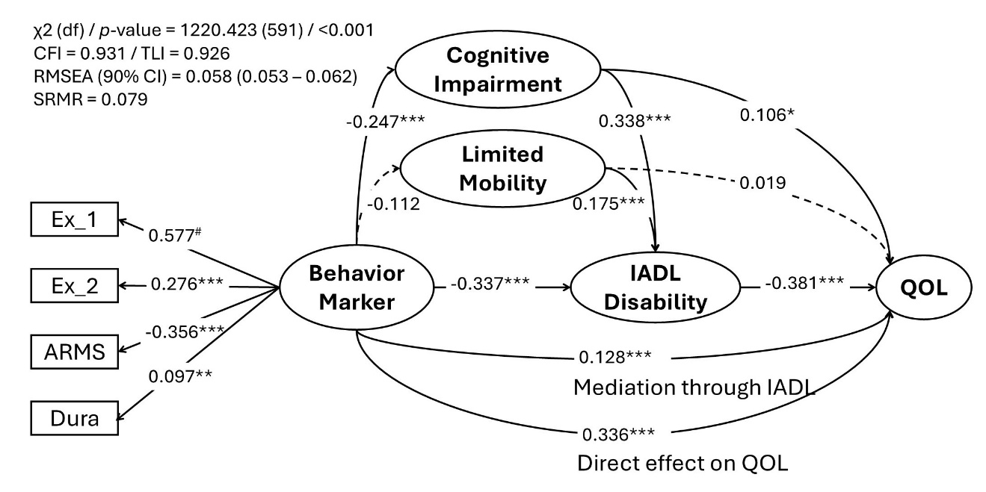

3. Supplementary Figure S1: Structural Equation Model for Behavior Markers, IC Domains, IADL, and QOL: Rectangular text boxes represent measured variables; elliptical text boxes represent latent variables. Solid arrow indicates a significant effect; dashed arrow indicates a non-significant effect. Numbers shown on the arrows are standardized coefficients. Age, sex, education, alcohol consumption, smoking, HTN, DM, cancer, and CKD stage were adjusted in this SEM. # factor loading constraint (fixed to define the scale of the latent variable), * p <0.05, ** p<0.01, *** p <0.001. Abbreviations: ARMS, Adherence to Refills and Medications Scale; CFI, comparative fit index; CI, confidence interval; df, degrees of freedom; Dura, enrollment duration to MDC program, Ex_1, frequency of any exercise; Ex_2, frequency of moderate intensity exercise; IADL, instrumental activities of daily living; effective MDC, effective multidisciplinary care by laboratory data-derived parameters; QOL, quality of life; RMSEA, root mean square error of approximation; SRMR, standardized root mean squared residual; TLI, Tucker-Lewis index.

